**Recruitment and Selection Process Management System:**

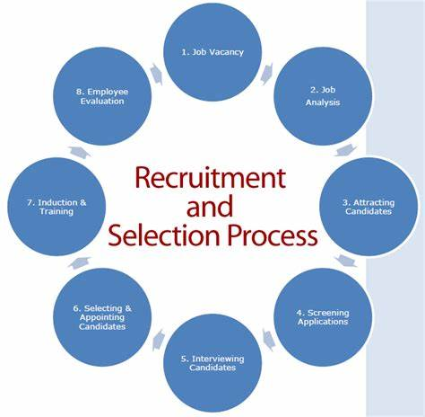

**1: Job Vacancy**

As a Human Resources Manager, I need to post a new job vacancy on the company's career portal to attract qualified candidates for the vacant position.

**Acceptance Criteria:**

**Given** that I am logged in to the company's HR system as an HR Manager  
**When** I navigate to the "Job Vacancies" section  
**Then** I should be able to create a new job vacancy listing

**2: Job Analysis**

`As a Human Resources Manager, I need to conduct a job analysis to gather detailed information about the responsibilities, qualifications, and performance expectations for a specific position within the company.

**Acceptance Criteria:**

**Given** that I am tasked with conducting a job analysis  
**When** I collaborate with relevant stakeholders, including department managers and team members  
**Then** I should be able to gather comprehensive data on job duties and requirements.

**3: Attracting Candidates:**

As a Recruitment Specialist, I need to attract qualified candidates for a job vacancy through various recruitment channels. So thatI can ensure a diverse pool of talented individuals for consideration and ultimately hire the best candidate for the job.

**Acceptance Criteria:**

**Given** that a job vacancy has been posted on the company's career portal  
**When** I create and distribute job postings on external job boards, social media platforms, and professional networks  
**Then** I should be able to reach a wide pool of potential candidates

**4: Screening Applications**

As a Hiring Manager, I need to screen incoming job applications to identify qualified candidates. So that I can efficiently and effectively identify the most suitable candidates to move forward in the hiring process.

**Acceptance Criteria:**

**Given** that I am reviewing job applications  
**When** I use predefined screening criteria to evaluate candidates  
**Then** I should be able to efficiently identify top candidates for interviews

**5 : Interviewing Candidate**

As a Hiring Manager, I need to conduct interviews with shortlisted candidates So that  
I can assess their qualifications, competencies, and fit for the role, ultimately selecting the most suitable candidate to fill the position.

**Acceptance Criteria:**

**Given** that I am conducting interviews  
**When** I ask relevant questions to assess candidate suitability  
**Then** I should be able to gather information to make informed hiring decisions

**6: Selecting and Appointing Candidates**

As a Hiring Manager, I need to select and appoint the most suitable candidate for the vacant position. So that I can ensure the successful fulfilment of the role with a qualified and capable individual who aligns with the company's needs and contributes to its growth and success.

**Acceptance Criteria:**

**Given** that I have selected a candidate  
**When** I extend a job offer  
**Then** I should be able to communicate the offer details and negotiate terms with the candidate

**7: Induction and Training**

As a Human Resources Manager, I need to facilitate the induction and training process for newly appointed employees. So that they can quickly acclimate to their roles, understand company policies and procedures, and develop the necessary skills to contribute effectively to the organization's goals and objectives.

**Acceptance Criteria:**

**Given** that the new employee has started  
**When** I schedule and coordinate orientation sessions and training programs  
**Then** I should ensure that the employee receives necessary information and training to perform their job effectively

**8: Employee Evaluation**

As a Human Resources Manager, I need to evaluate employee performance periodically to assess their contributions and provide feedback So that I can support employees in their professional growth, identify areas for improvement, and recognize and reward exceptional performance.

**Acceptance Criteria:**

**Given** that I have completed performance evaluations  
**When** I provide feedback and discuss development opportunities with employees  
**Then** I should be able to support their growth and career progression within the compan

**Scrum Framework:**  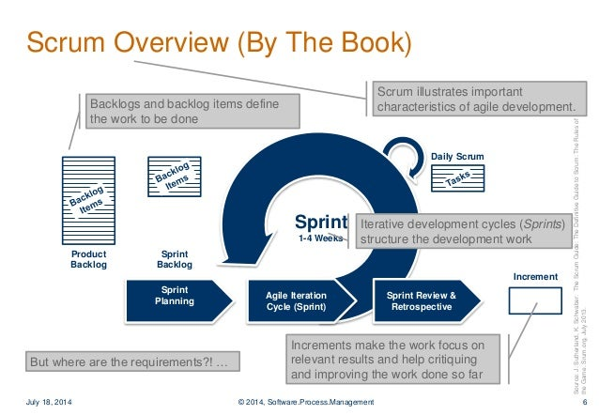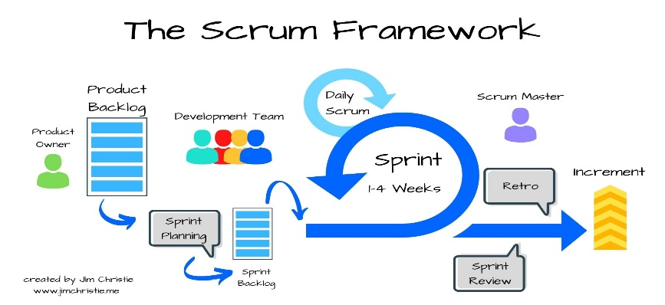

**Scrum:** Scrum is an **agile framework** for managing and delivering complex projects, primarily in software development, but it has been widely adopted in various other fields as well.

**1.Product Owner:**

The Product Owner is a member of the Scrum Team and works closely with both the Development Team and stakeholders to ensure that the product backlog is well-defined, prioritized, and understood.

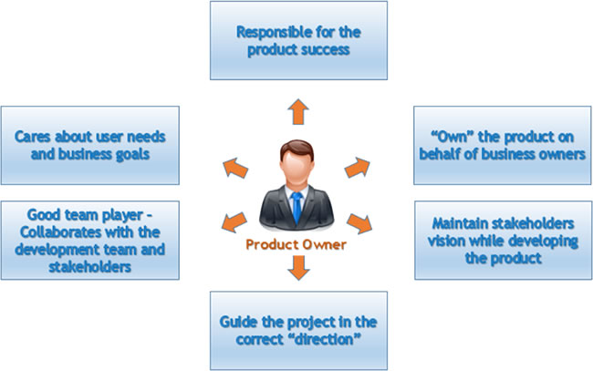

**2.Product Backlog:**

* Requirements for the entire product.
* Owned by product owner.
* Term used in agile project.
* In the form of User stories, Features and Epics.
* Ordered based on the business priority number.
* Technical stories to enable the product features.
* Current status of each user story will be captured in the Product Backlog.

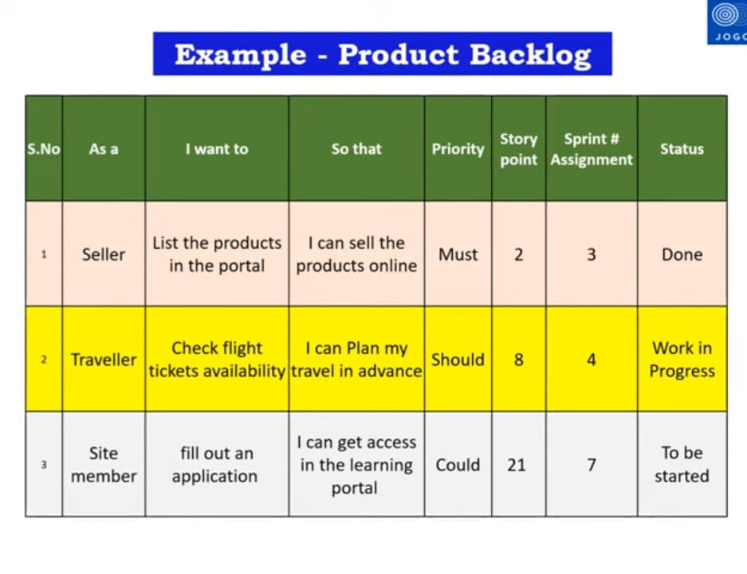

**3.Sprint Planning:** Sprint Planning is a key event in the Scrum framework that occurs at the beginning of each Sprint.

It is a collaborative meeting where the Scrum Team (including the Product Owner, Scrum Master, and Development Team) comes together to plan the work that will be completed during the upcoming Sprint.

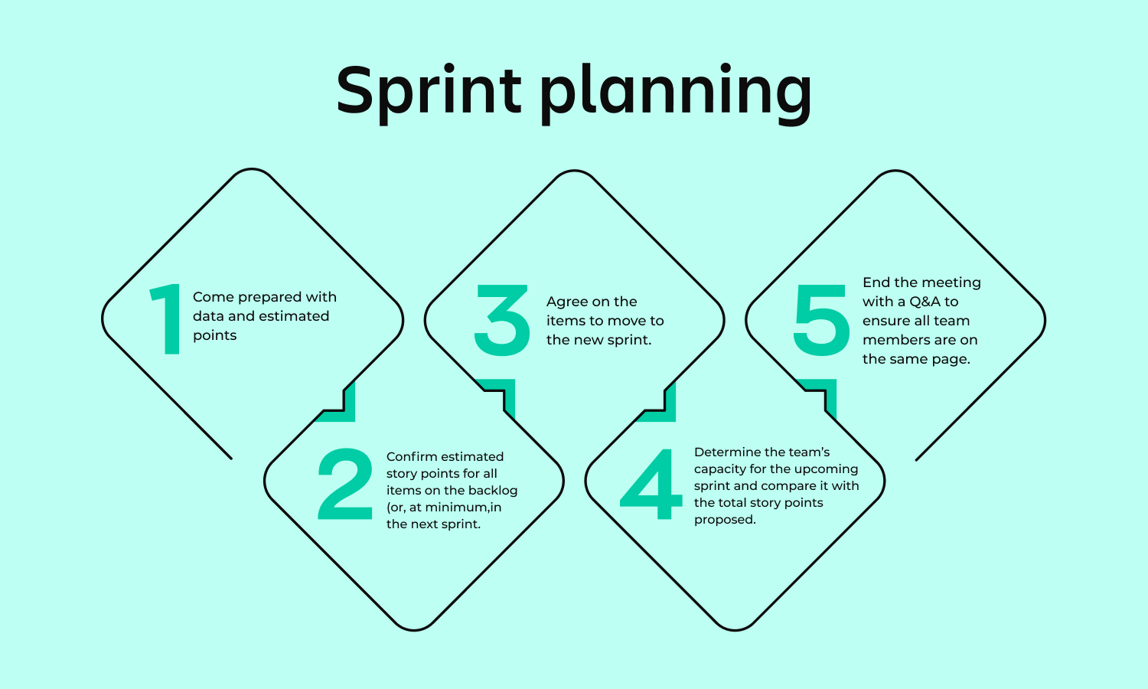

**4. Sprint Backlog:** Subset of the Product Backlog items selected for implementation in the current Sprint.

* Owned by the development team.
* Technical tasks related to user stories.
* Effort estimates in hours for tasks.
* Identifies as part of sprint planning meeting.

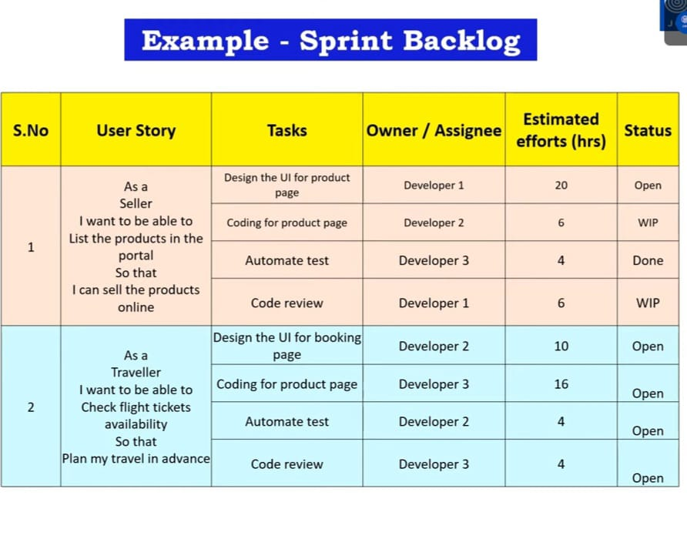

**5. Sprint:**

* Sprint is a time-boxed iteration during which a specific amount of work is completed by the Development Team.
* Sprints are a fundamental aspect of the Scrum framework and typically have a fixed duration, usually ranging from one to four weeks.
* The duration of a Sprint is determined during the project's initial planning and remains consistent throughout the project.
* Sprints in Scrum provide a structured approach to iterative and incremental development, allowing teams to deliver value in regular, predictable intervals while maintaining flexibility and adaptability to changing requirement.

**Key aspects of Sprints in Scrum :**

* **Daily Stand-up:** Throughout the Sprint, the Development Team holds a Daily Stand-up meeting to synchronize their activities, discuss progress, and identify any obstacles or impediments that may affect their ability to achieve the Sprint Goal.
* **Increment:** The Increment is the sum of all the completed and potentially shippable product backlog items at the end of the Sprint. It represents the work completed by the Development Team during the Sprint and serves as the foundation for the next Sprint.

**6. Sprint Review :**

* The Sprint Review is an essential event in the Scrum framework that occurs at the end of each Sprint.
* The Sprint Review concludes with a review of the Sprint Goals and objectives. The Scrum Team discusses whether the Sprint Goals were achieved and identifies any areas for improvement.

**7.** **Sprint Retrospective:**

* Insights and lessons learned from the Sprint Retrospective, which is held immediately after the Sprint Review, may also inform discussions during the Sprint Review.
* The Sprint Retrospective focuses on process improvements and team dynamics, providing valuable insights that can help enhance future Sprint Reviews and overall product development.

**8.** **Increment:**

* The Increment is the sum of all the completed and potentially shippable product backlog items at the end of the Sprint. It represents the work completed by the Development Team during the Sprint and serves as the foundation for the next Sprint.

**9. Scrum Master:**

* Scrum Master plays a pivotal role in enabling the Scrum Team to deliver value effectively and efficiently.
* They serve as a facilitator, coach, mentor, and servant-leader, helping the team navigate challenges, overcome obstacles, and achieve their goals within the Scrum framework.

Top of Form